BED 106 — BUSINESS ANALYTICS
Mini Business Analytics Capstone Project
Checkpoint 2: Statistical Analysis, Performance Metrics, Initial Visualization
Midterm Period — Weeks 5–8
Project Title: RetailPulse — Poblacion Grocery Mart
Business Domain: Retail & Sales Analytics
Group: Arowana Kings
Group Members and Roles:
Member Name | Role | Component
Angel Frederick Paredes | Lead Developer / Project Lead | Statistical analysis, correlation testing, dashboard visualizations, report compilation
Jeeruz Marl Tabar | Research Support | Verified data definitions used in descriptive statistics
Luke Kibry Jao | Testing Support | Manual testing of pivot tables and chart outputs
Clein Lord Will Surigao | Documentation Review | Reviewed checkpoint write-up and final report
Instructor: Jessie A. Melendres
Talibon Polytechnic College
A.Y. 2026–2027 | 1st Semester

Section 1 — Statistical Analysis

1.1 Descriptive Statistics
Descriptive statistics were computed on total revenue and total units sold, aggregated per product (n = 40 products), using the cleaned poblacion_grocery_mart dataset (2,532 transactions, 10,087 line items).
Metric | Total Revenue per Product (₱) | Units Sold per Product
Mean | 69,490.68 | 727.25
Median | 33,408.00 | 755.00
Standard Deviation | 105,410.26 | 114.45
Minimum | 2,328.00 | 371
Maximum | 589,000.00 | 894

Outlier Identification
Outliers were flagged using two methods: a revenue z-score threshold of |z| > 1.0, and the standard 1.5×IQR rule (Q1 = ₱21,380.50, Q3 = ₱62,605.50, IQR = ₱41,225.00). Five products were flagged as high-revenue outliers by at least one method; no low-revenue outliers were found by the z-score method, since the distribution is right-skewed (mean > median) rather than having unusually low performers.
Product | Category | Total Revenue (₱) | Revenue Z-Score | Flag
Rice 25kg Sack (NFA) | Rice & Staples | 589,000 | 4.93 | High outlier
San Miguel Beer (case) | Beverages | 296,400 | 2.15 | High outlier
Dinorado Rice 5kg | Rice & Staples | 234,880 | 1.57 | High outlier
Sinandomeng Rice 5kg | Rice & Staples | 204,880 | 1.28 | High outlier
Purefoods Hotdog 1kg | Frozen & Dairy | 145,540 | 0.72 | High outlier (IQR only)
Table — Products flagged as revenue outliers (z-score and/or IQR method)
These five products are our anchor items — they generate disproportionately large revenue relative to the rest of the catalog, so stockouts on any of them would hit total sales much harder than a stockout on a typical product. Rice 25kg Sack (NFA) alone is nearly 5 standard deviations above the mean, meaning it behaves less like a normal product and more like a separate, high-priority category that deserves its own reorder point and safety stock buffer rather than being managed with the same rules as the other 35 products.

1.2 Correlation Analysis
Correlation coefficients (Pearson's r) were computed across the 40 products to test the relationship between sales performance and profitability:
Variables Compared | Correlation (r) | Strength & Direction
Total Revenue vs. Total Profit | 0.97 | Very strong positive
Units Sold vs. Total Profit | -0.58 | Moderate negative
Total Revenue vs. Profit Margin % | -0.71 | Strong negative
Units Sold vs. Profit Margin % | 0.44 | Moderate positive
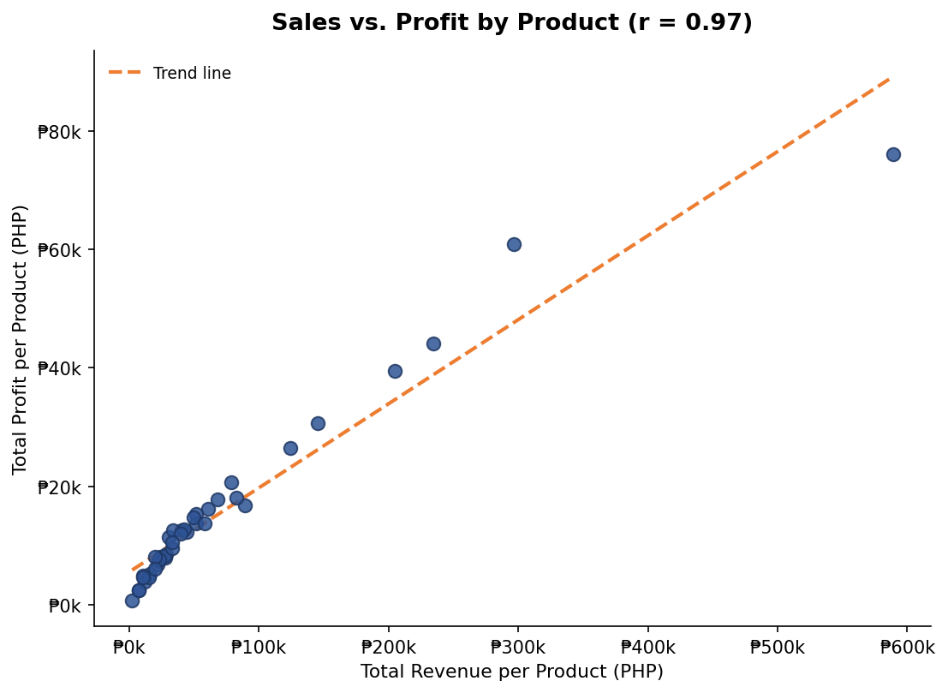
Figure — Total revenue vs. total profit per product, with linear trend line (r = 0.97)
Not exactly — high-selling products do yield high profit in pesos (r = 0.97 between revenue and profit), but that's mostly because bigger sales volume produces a bigger absolute profit even at a thin margin. The margin percentage itself actually falls as revenue rises (r = -0.71 between revenue and profit margin %), so our best peso-profit earners, like Rice 25kg Sack, are not our most profitable products on a per-peso-of-sales basis — they win on volume, not on margin.

Section 2 — Performance Metrics

2.1 Top 10 Products by Revenue
Rank | Product | Category | Units Sold | Revenue (₱)
1 | Rice 25kg Sack (NFA) | Rice & Staples | 380 | 589,000
2 | San Miguel Beer (case) | Beverages | 380 | 296,400
3 | Dinorado Rice 5kg | Rice & Staples | 734 | 234,880
4 | Sinandomeng Rice 5kg | Rice & Staples | 788 | 204,880
5 | Purefoods Hotdog 1kg | Frozen & Dairy | 766 | 145,540
6 | Frozen Galunggong 1kg | Frozen & Dairy | 754 | 124,410
7 | Eggs (per tray of 30) | Frozen & Dairy | 371 | 89,040
8 | Magnolia Fresh Milk 1L | Frozen & Dairy | 720 | 82,800
9 | Argentina Corned Beef 380g | Canned Goods | 826 | 78,470
10 | Tide Powder Detergent 1kg | Household Supplies | 741 | 68,172

2.2 Category Contribution to Total Sales
Total store revenue across the 6-month period: ₱2,779,627. Total store profit: ₱615,376.
Category | Units Sold | Revenue (₱) | % of Total Sales
Rice & Staples | 1,902 | 1,028,760 | 37.01%
Frozen & Dairy | 3,251 | 491,710 | 17.69%
Beverages | 3,495 | 427,095 | 15.37%
Canned Goods | 3,963 | 203,989 | 7.34%
Household Supplies | 3,883 | 178,717 | 6.43%
Personal Care & Hygiene | 3,541 | 150,360 | 5.41%
Snacks & Biscuits | 3,547 | 127,248 | 4.58%
Condiments & Seasoning | 3,095 | 103,846 | 3.74%
Bread & Bakery | 2,413 | 67,902 | 2.44%

2.3 Profitability by Category
Categories ranked by profit margin (total profit ÷ total revenue), rather than by raw sales volume:
Category | Revenue (₱) | Profit (₱) | Profit Margin %
Personal Care & Hygiene | 150,360 | 50,786 | 33.78%
Household Supplies | 178,717 | 52,585 | 29.42%
Canned Goods | 203,989 | 58,699 | 28.78%
Condiments & Seasoning | 103,846 | 33,312 | 32.08%
Snacks & Biscuits | 127,248 | 38,951 | 30.61%
Bread & Bakery | 67,902 | 16,985 | 25.01%
Beverages | 427,095 | 98,173 | 22.99%
Frozen & Dairy | 491,710 | 106,445 | 21.65%
Rice & Staples | 1,028,760 | 159,440 | 15.50%
Table — Categories sorted by profit margin percentage, highest to lowest
Rice & Staples is the clearest example of the high-volume, low-margin pattern — it brings in 37% of total revenue but converts only 15.50% of that into profit, the lowest margin of any category. Personal Care & Hygiene is the opposite case: it's one of the smallest revenue contributors (5.41% of sales) but has the highest margin at 33.78%. This suggests the store shouldn't just chase revenue growth in Rice & Staples — it should also actively promote and cross-sell higher-margin categories like Personal Care & Hygiene and Household Supplies to improve overall profitability, not just overall sales.

Section 3 — Initial Visualization

3.1 KPI Cards
TOP PRODUCT  Rice 25kg Sack (NFA)  ₱589,000 revenue | TOP CATEGORY  Rice & Staples  37.0% of total sales | TOTAL REVENUE  ₱2,779,627  Jan – Jun 2026

3.2 Top 10 Products — Bar Chart
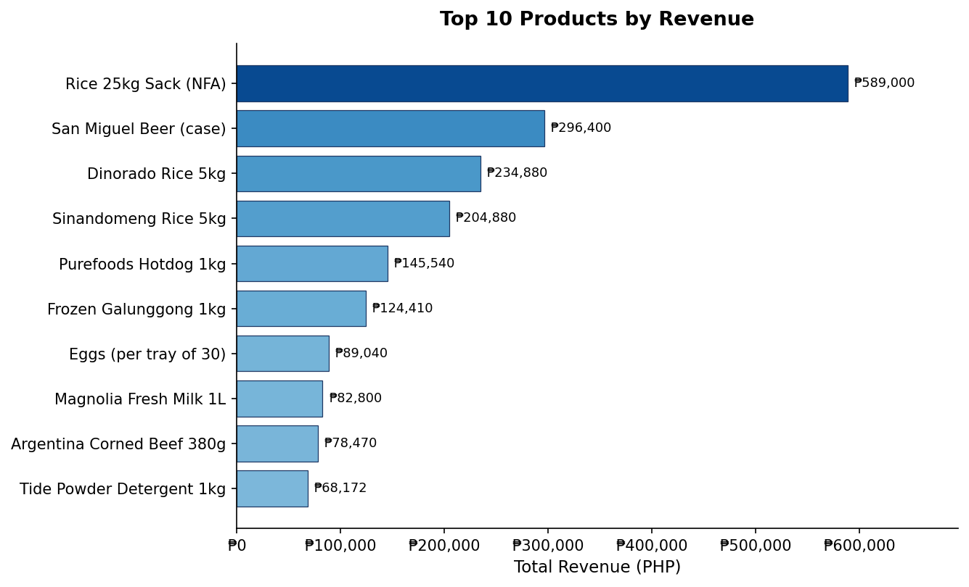
Figure — Top 10 products ranked by total revenue

3.3 Category Revenue Share — Pie Chart
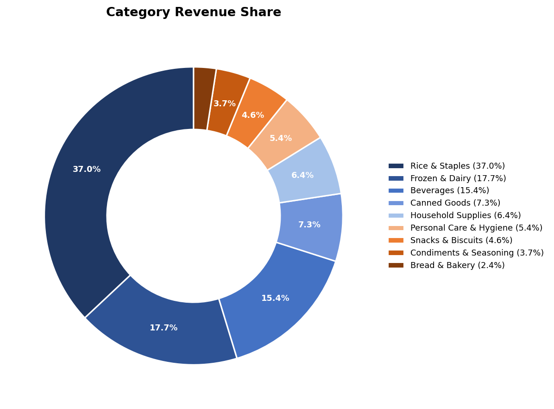
Figure — Percentage contribution of each category to total store revenue

Section 4 — Key Insights
Following the example format from the checkpoint brief (e.g., "Technology contributes 45% of total revenue, with Laptops being the single highest-selling product"), state 2–3 headline insights from your own analysis above.
Rice & Staples contributes 37.01% of total store revenue (₱1,028,760), making it by far the single largest revenue-driving category in the store.
Despite generating the most revenue, Rice & Staples has the lowest profit margin of any category at 15.50%, while Personal Care & Hygiene earns the highest margin at 33.78% on far less revenue — showing that the store's top seller and its most profitable category are not the same thing.
The 5 flagged high-revenue outlier products come from only 3 categories (Rice & Staples, Beverages, Frozen & Dairy), suggesting the store's overall sales performance is heavily concentrated in a small number of anchor products rather than spread evenly across the full 40-product catalog.

